Jada Richard
richjada1@gmail.com | 904-566-5713 | Tallahassee, FL 32311

Professional Summary________________________________________________
Equipped with strong problem-solving abilities, willingness to learn, strong communication skills with a solid foundation in research and campaign management. Ready to tackle new challenges and advance organizational objectives with dedication and enthusiasm. Energetic, innovative and dedicated to driving brand awareness and fostering positive public relations to achieve impactful results that contribute to team success.

Education_______________________________________________________________
Florida Agricultural & Mechanical University (FAMU) Tallahassee, FL
Bachelor’s Applied Science/ Political Science Currently Enrolled

Florida State College at Jacksonville Jacksonville, FL
Associate in Science May 2021

Community Service & Volunteer Experience_________________________________
Tallahassee Aids Walk Tallahassee, FL
Volunteer June 2024
- Assisted in planning and executing the annual AIDS Walk event to raise awareness and funds for HIV/AIDS research and community support services.
- Registered participants, distributed event materials, and provided logistical support to ensure a smooth event experience.
- Collaborated with local organizations and vendors to promote health education and community engagement.
- Helped manage set-up and clean-up efforts, demonstrating strong teamwork and time management skills.
- Contributed to social media outreach and participant follow-ups, supporting efforts to boost event turnout and donor engagement.

UNF Explore Program Jacksonville, FL
Peer Volunteer May 2022
- Encouraged student involvement and provided campus resource information.
- Led group discussions and activities to students that explained different programs at UNF.
- Collaborated with UNF team to ensure smooth event logistics.

Pace Center for Girls Jacksonville, FL
Peer Mentor March 2022
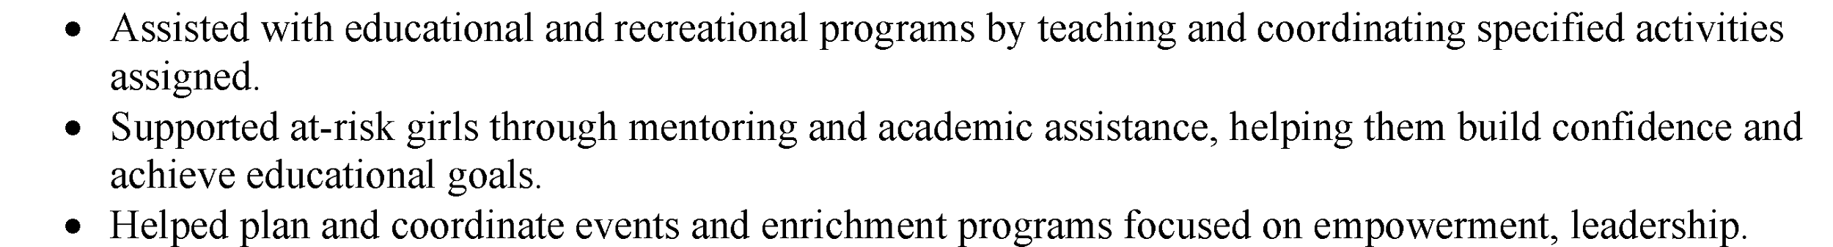

Extracurricular Leadership Involvement____________________________________
Reigning Miss Gold – Alpha Phi Alpha Fraternity, Inc.
Academic Year 2021–2022
- Represented the fraternity in campus and community events.
- Supported chapter initiatives and mentored participants.

Miss Black and Gold Pageant- Beta Nu Chapter, Alpha Phi Alpha Fraternity, Inc.
Pageant Assistant Director & Choreographer
Dec. 2022–Current
- Directed and choreographed pageant performances.
- Mentored contestants and managed event planning and logistics.

MYPink Sisters – Breast Cancer Foundation
April 2020- Current
- Participated in outreach activities and events supporting breast cancer awareness and survivors.

Honors & Awards______________________________________________________
Dean’s List (FAMU): Spring 2025, Fall 2023, Spring 2023
University Honors List (FAMU): Fall 2024, Spring 2024, Fall 2023, Fall 2022

References______________________________________________________________
Available upon request

